DELIGHTFUL ANTALYA & ISTANBUL
ISTANBUL AYDIN UNIVERSITY
INTERNATIONAL WINTER SCHOOL
14 -28th January 2016
PROGRAM DETAILS

14th – 20th January Antalya Part
Accommodation in Club Hotel Falcon on full board basis.
14th January Saturday
- Participants arrival to the Antalya International Airport. Transfer service from the airport to the Falcon Hotel will be available. Times of the pickup service and the details will be communicated with the participants.
- Check in to the Club Hotel Falcon Antalya ‘’Falcon hotel prepares a magnificent opportunity where you can enjoy a unique time in the company of the glorious views of the Mediterranean and the Toros mountains, where you can be entertained while relaxing both away from the crowds of the city and at its very heart.’’
- Accommodation in shared rooms
- Registration to the Delightful Winter Program ( Participants will be receiving their Program Bags, Museum Cards and Badges )
- Orientation Meeting with the participants
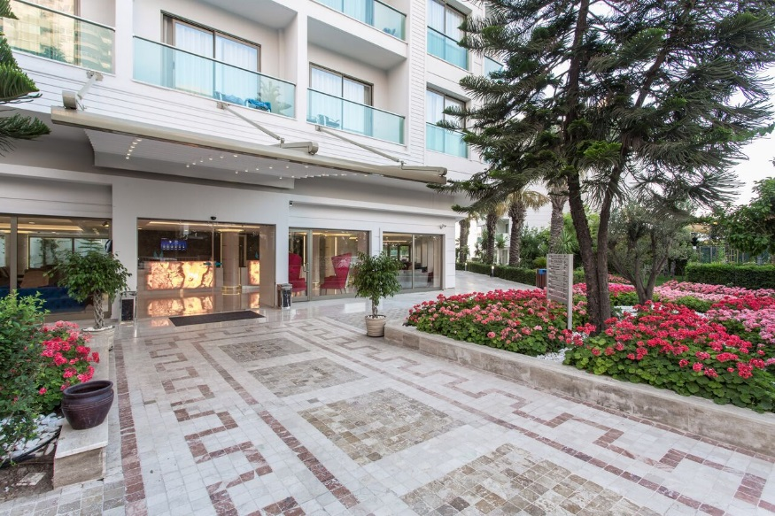

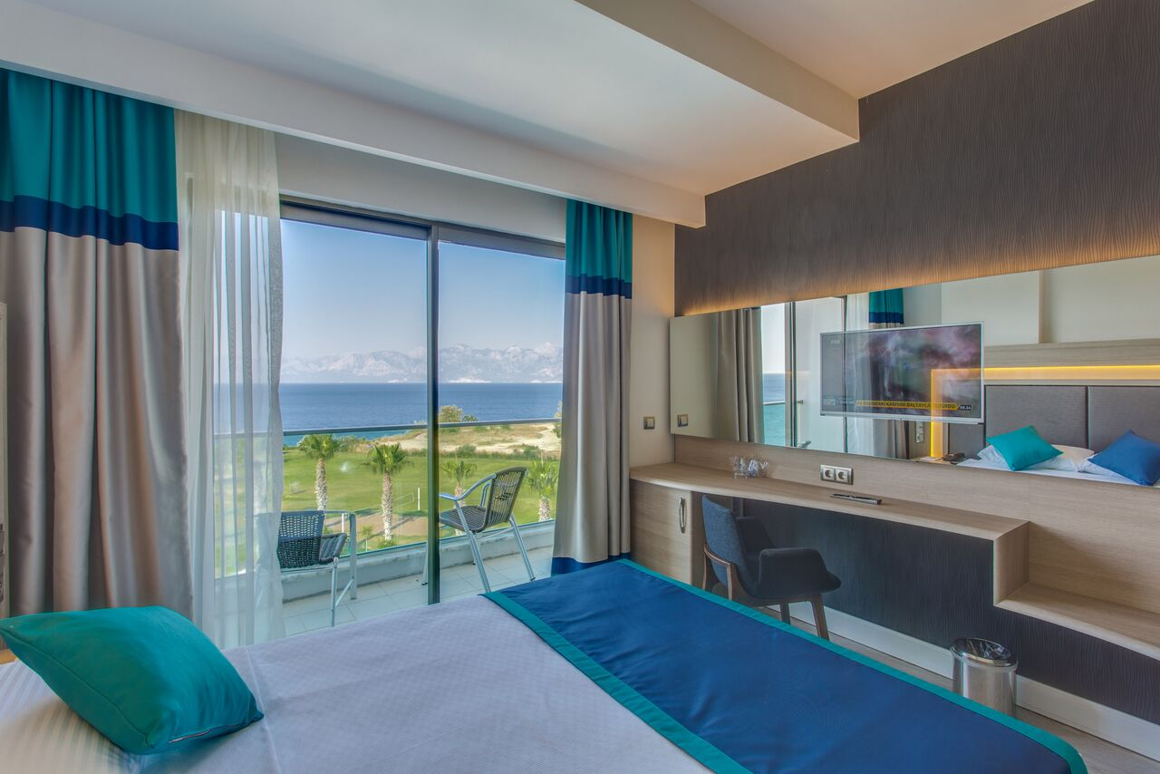

15th January Sunday
Professionally Guided Tour (Optional) “Side – Aspendos – Perge” including lunch
Price: 120.tl or 40 Euro or 45 USD
Departure with busses after the breakfast at Falcon Hotel
- There will be a daily tour (optional) covering the three most spectacular places around Antalya, Perge (Perge was once the capital city of the Pamphylia region. During your visit, you will be able to seeThe Stadium, Roman Gate, Nymphaeum, Roman Bath, Hellenistic Gate, The Column Street and The State Agora. )
- Aspendos Ancient Theatre (Aspendos is the best preserved and the most complete example of a Roman theatre in Turkey. The theatre was still in use for concerts, festivals and events until recently.)
- And also we will be visiting The Side Ancient City where you will see the splendid Agora, Theatre and Temples built in the 17th century B.C.
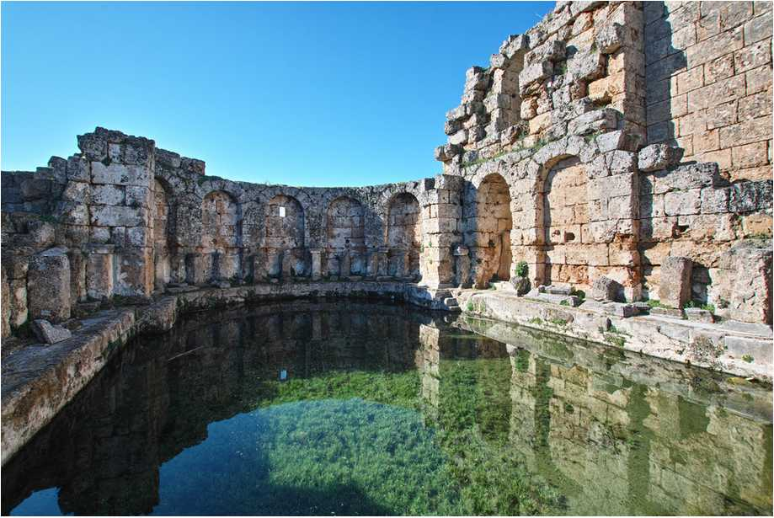
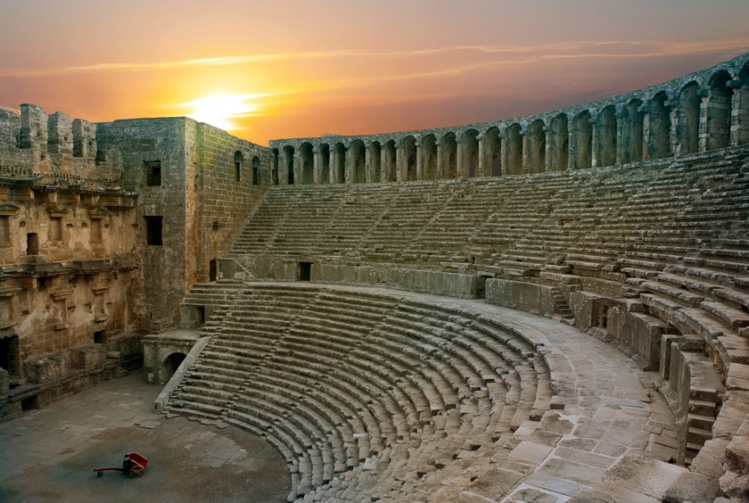

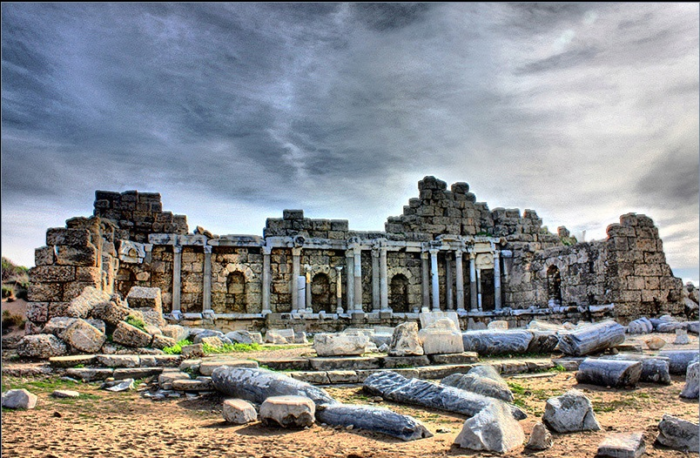

16th January Monday
- Courses Start 08:30 – 12:30
- Lunch 12:30 – 13:30
- Free Time 13:30 – 14:00

Antalya Old Town “Kale İçi” Tour with Proffessional Guide ( Optional )
Price : 40 TL or 12 Euro or 15 USD
Among some of the spots included in this tour are; Yivli Minare Mosque, Singing Fountain, Clock Tower, Hadrian's Gate, Old Historic Bazaar (Carsi), Club Ally.
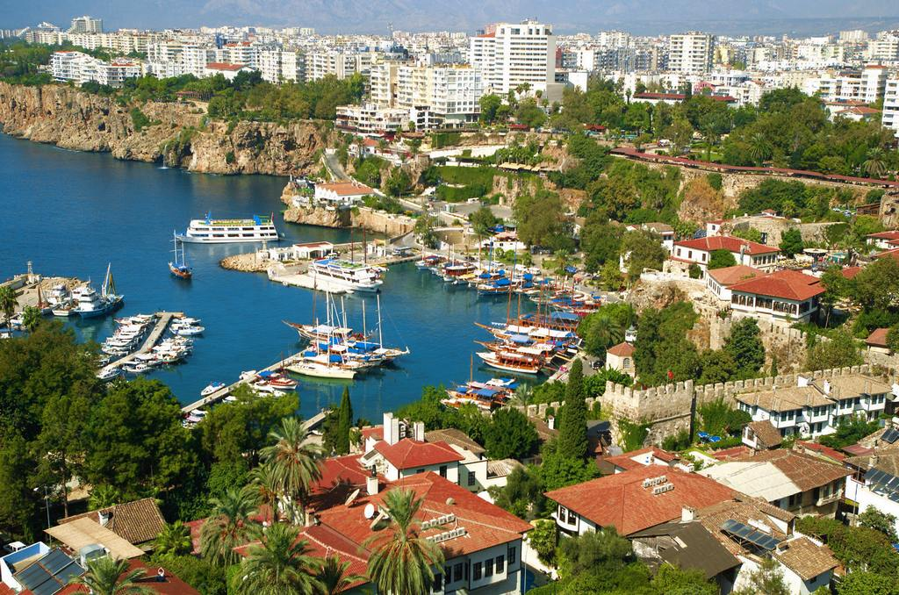

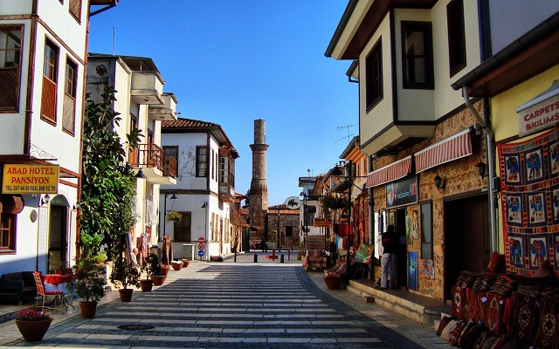

17th January Tuesday

- Courses Start 08:30 – 12:30
- Lunch 12:30 – 13:30
- Free Time 13:30 – 14:00

Phaselis & Tahtalı (optional) Tour with Professional Guide
Price: 85 TL or 25 Euro or 30 USD
This time we will be driving to the west of Antalya. A day trip to the top of the Taurus Mountains with Kemer on one side and the blue sea of Mediterranean on the other. Enjoy the drive through the forested mountain roads to reach Tahtali and go on a fifteen minute cable car ride to get to the mountain peak at 2365m. You will enjoy a breathtaking view of the whole of Antalya. We recommend you take your camera to capture this truly unforgettable site while enjoying the Cedar covered slopes.
Next we visit Phaselis which was founded in the year 690 BC as a colony of Rhodes. The three harbors of Phaselis were the reason for its historical role as a commercial center. The ruins of Aqueduct, Agora, Baths, Theatre, Hadrian's Gate and an Acropolis underline the city's historical importance.
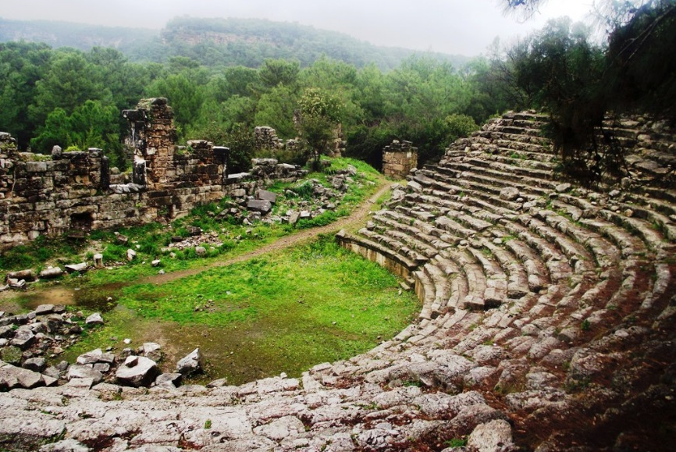

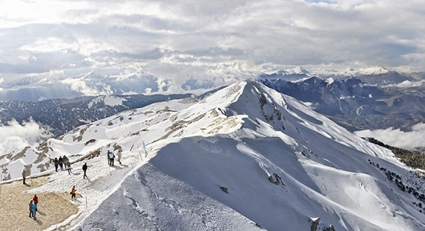

18th January Wednesday
- Courses Start 08:30 – 12:30
- Lunch 12:30 – 13:30
- Free Time 13:30 – 14:00
- Afternoon free time around Lara and in the Hotel

19th January Thursday
- Courses Start 08:30 – 12:30
- Lunch 12:30 – 13:30
- Free Time 13:30 – 14:00
Duden Water Falls and Kursunlu Tour (optional) with Professional Guide
Price: 55 TL or 18 Euro or 20 USD
The waterfall, formed by the Düden River (one of the major rivers in southern Anatolia), is located 12 km north-east of Antalya; which ends, where the limpid waters of the Lower Düden Falls drop off a rocky cliff directly into the Mediterranean Sea in a dazzling show. The Kurşunlu Waterfall is located 19 km from Antalya, Turkey at the end of a 7 km road branching off to the north of the Antalya-Serik-Alanya highway at a point 12 km from Antalya. The waterfall is on one of the tributaries of the Aksu River and its situation in the midst of a pine forest is of quite exceptional beauty.
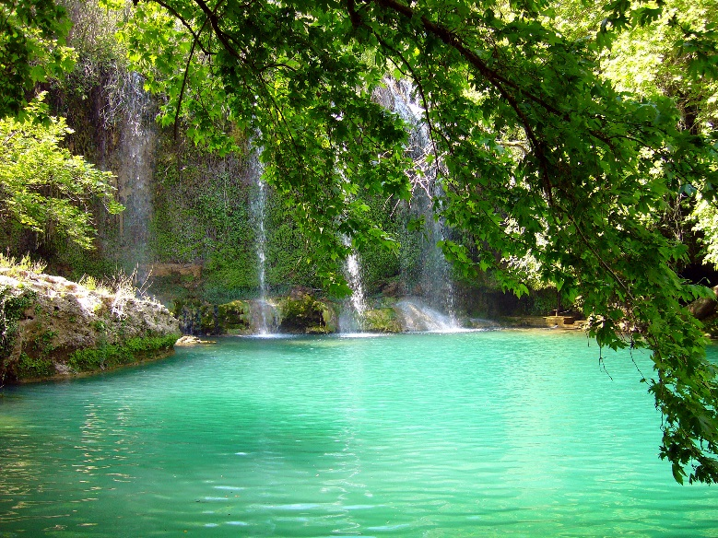
,

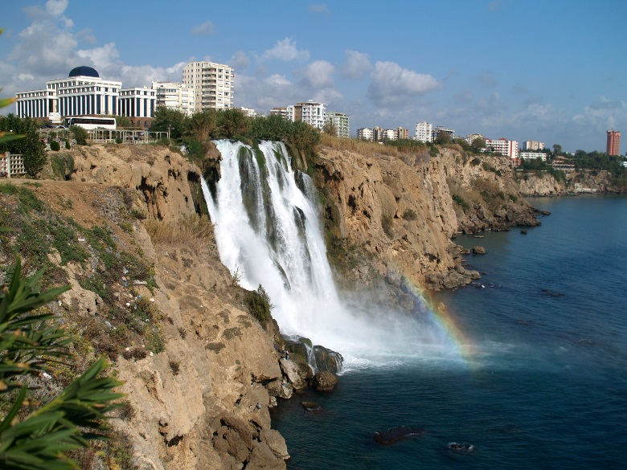

20th January Friday

- Courses Start 08:30 – 12:30
- Lunch 12:30 – 13:30
- Free Time 13:30 – 14:00
- Transfer to the Antalya Domestic Airport
- Flight to Istanbul ( Participants must arrange their flight tickets for the flight from Antalya to Istanbul on the 22nd Jan, Friday Afternoon before they come to the program)

20th – 28th January İstanbul Part
Accommodation at hostel near IAU
Meals are not included in the program between 22ndevening until the end of the program

20th January Friday
- Arrival to the Ataturk Domestic Airport Terminal and transfer to the hostel
- Check in at the hostel
- Evening Free

21st January Saturday
- Topkapı Palace & Hagia Sophia & Blue Mosque Tour ( Included in the Program Fee )
A Full day tour with professional tour guide including light lunch will cover those not to miss attractions of Istanbul old town.

22nd January Sunday
- Bophorus by Boat ( Included in the Program Fee )
A Full day tour including light lunch will take you to the magnificent view of Bosphorus.

23rd January Monday
- Morning Courses 09:30 – 12:30
- Break 12:30 – 13:30
- Afternoon Courses 13:30 – 15:00

24th January Tuesday
- Photo Shooting with Traditional Clothes 09:00 – 09:30
- Morning Courses 09:30 – 12:30
- Break 12:30 – 13:30
- Afternoon Courses 13:30 – 15:00
- Tour to Aqua Florya Europe’s Biggest Thematic Aquarium ( Tour includes entrance tickets to Aquarium, visiting one of the newest shopping malls overlooking the magnificent Marmara Sea and Dinner.

Price: 85 TL or 25 Euro or 30 USD

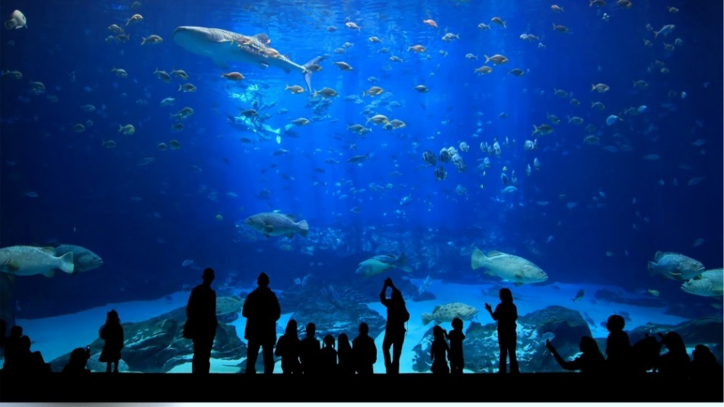

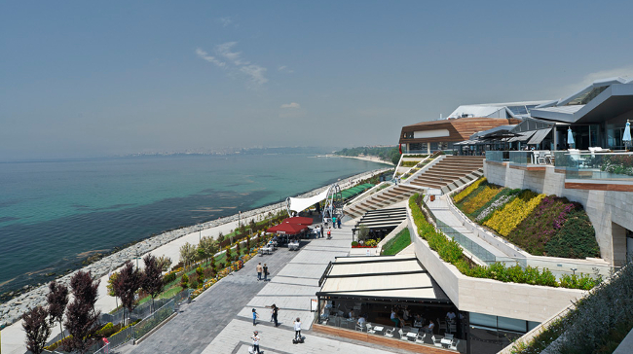

25th January Wednesday

- Morning Courses 09:30 – 12:30
- Break 12:30 – 13:30
- Afternoon Courses 13:30 – 15:00
Taksim & Istiklal Street and Galata Tower Tour with Professional Guide
Tour to Istiklal Street Taksim. Istiklal Avenue or Istiklal is one of the most famous avenues in Istanbul visited by nearly 3 million people in a single day over the course of weekends. Located in the historic Beyoğlu (Pera) district, it is an elegant pedestrian street, 1.4 kilometers long, which houses boutiques, music stores, bookstores, art galleries, cinemas, theatres, libraries, cafés, pubs, night clubs with live music, historical patisseries, chocolatiers and restaurants. The avenue, surrounded by late Ottoman era buildings (mostly from the 19th and early 20th centuries) that were designed with the Neo-Classical, Neo-Gothic, Renaissance Revival, Beaux-Arts, Art Nouveau and First Turkish National Architecture styles.
Price: 40 TL or 12 Euro or 15 USD
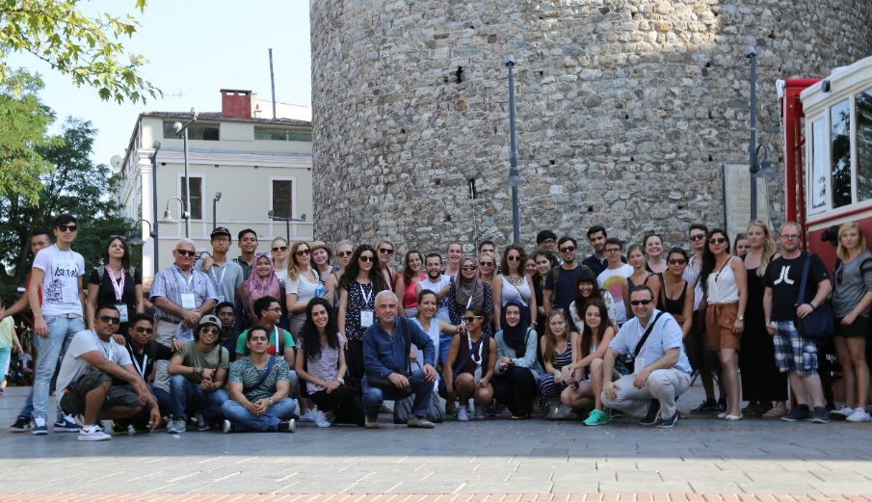

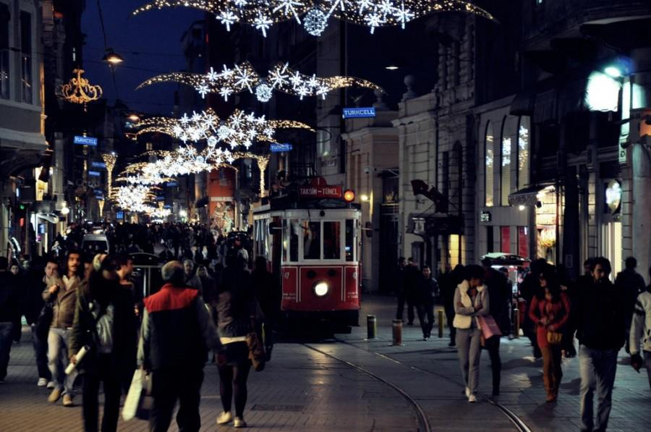

26th January Thursday

- Morning Courses 09:30 – 12:30
- Break 12:30 – 13:30
- Afternoon Courses 13:30 – 15:00
Tour to Spice Bazaar & Galata Bridge & Dinner at Galata Bridge
Spice Bazaar in Istanbul, Turkey is one of the largest bazaars in the city. The building was endowed to the foundation of the New Mosque, and got its name "Egyptian Bazaar” because it was built with the revenues from the Ottoman province of Egypt in 1660.
The Galata Bridge is a bridge that spans the Golden Horn in Istanbul, Turkey. From the end of the 19th century in particular, the bridge has featured in Turkish literature, theater, poetry and novels.

Price: 85 TL or 25 Euro or 30 USD
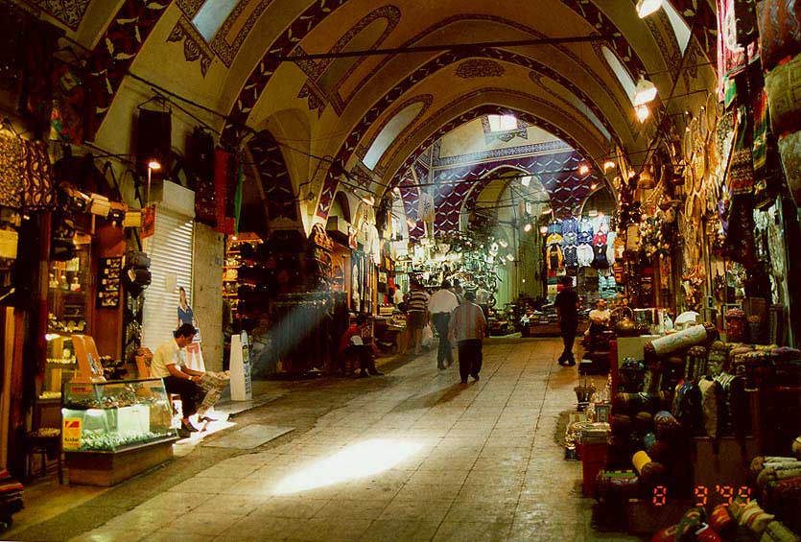

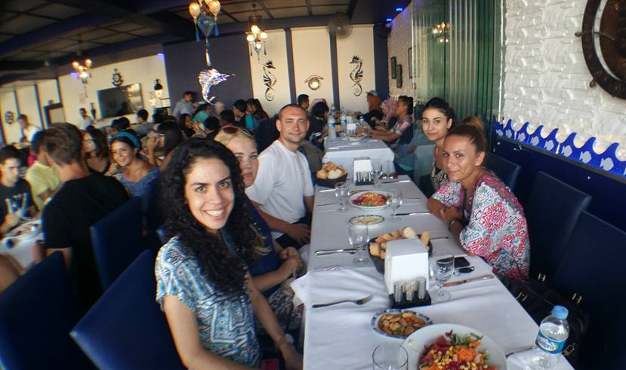

27th January Friday

- Last Discussions with Lecturers 09:30 – 12:30
- Break 12:30 – 13:30
- Graduation Ceremony 13:30 – 16:00

Bosphorus by Night Tour by Boat, Shows & Dinner on Boat
We leave by boat from Golden Horn, cruising all the way towards the Black sea enjoying the magnificent view of Bosphorus by night. We will be viewing lots of surprise shows on the boat while enjoying our open buffet dinner.
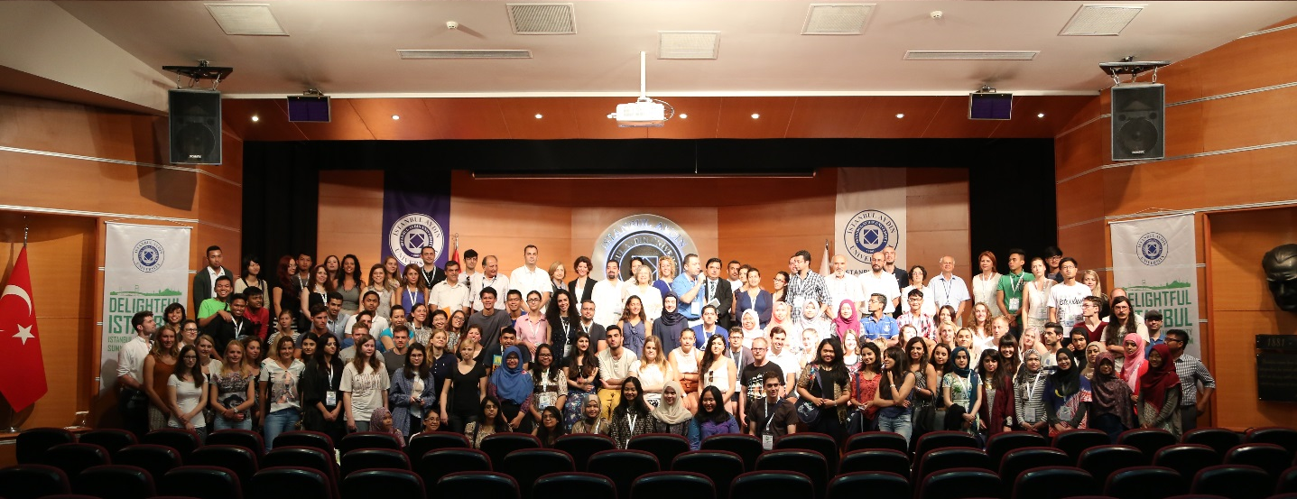
Price : 85 TL or 25 Euro or 30 USD
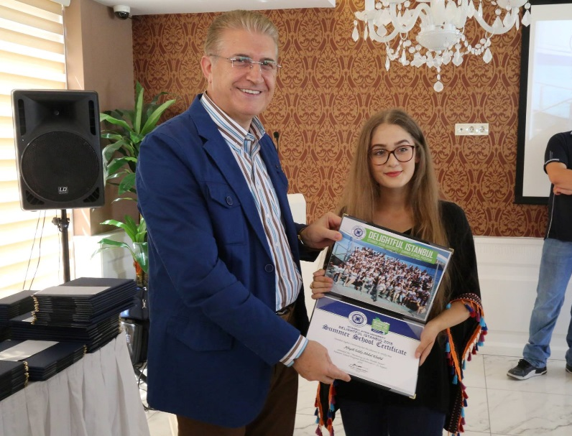
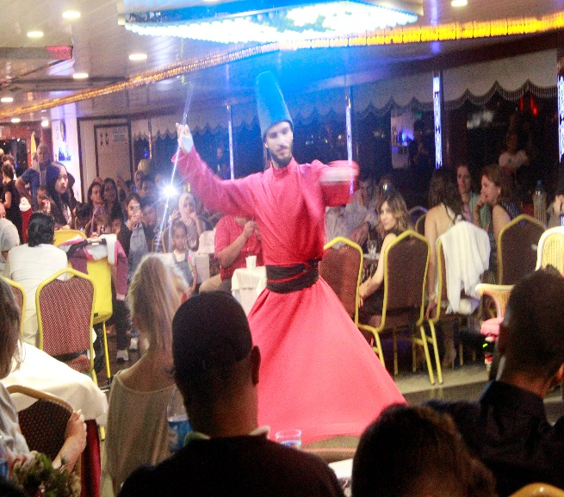j

